***Forking and Pull Requests***

Forking is copying other repositories in your own repository.

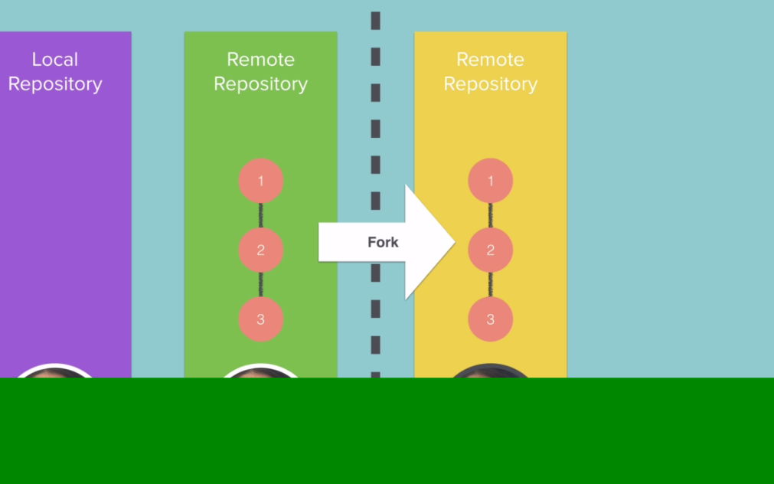

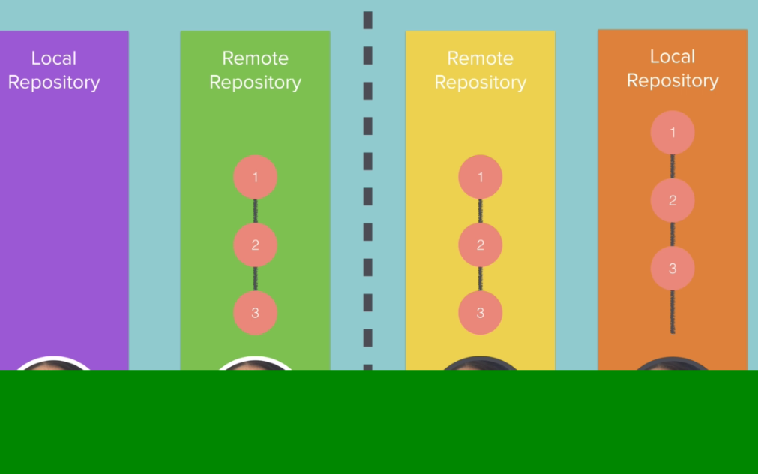

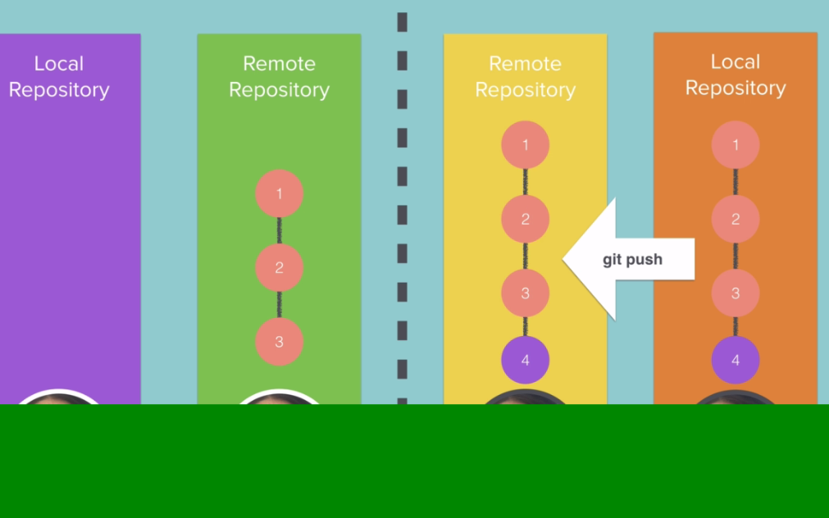

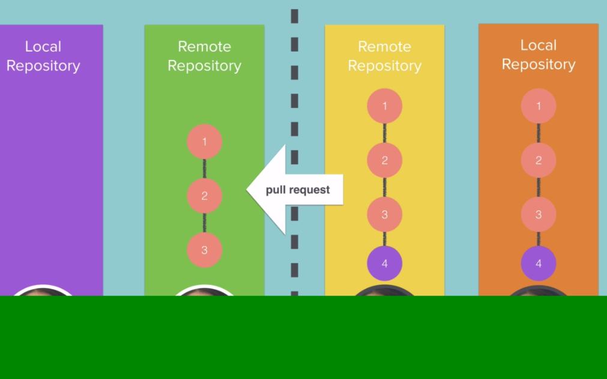

Pull request not push.

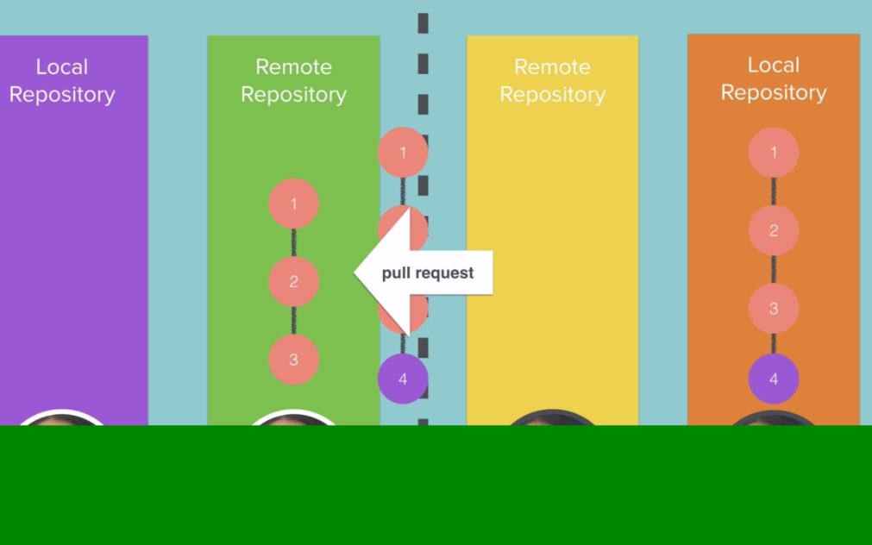

Merge repository with my repository.

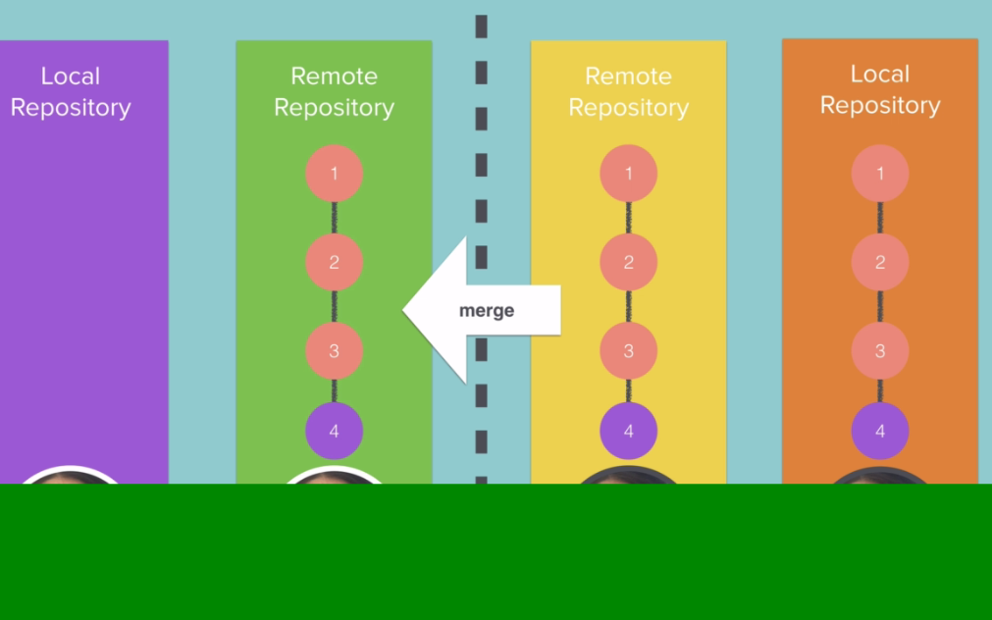

Let’s do fork from Angela account. Everything will be same you can see.

forked link:

<https://github.com/MuhammadAhmad123a/AngelaBauer_Story>



